# Enter time (web clock users):

Step 1: from the home page click on the Time Worklet

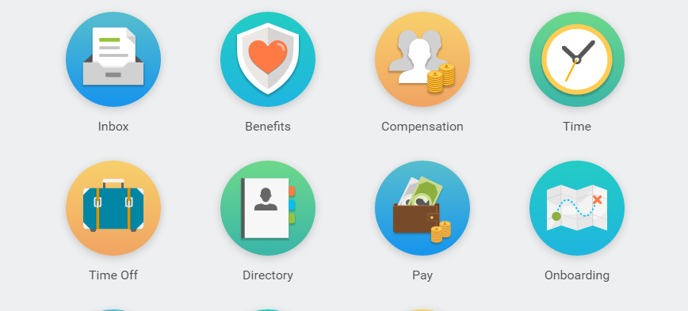

Step 2: Click Check In

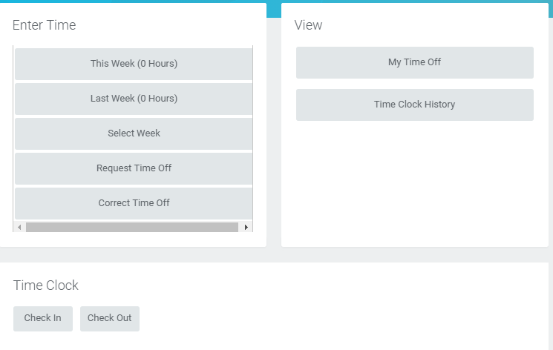

Step 3: enter the Time Type and Details and click OK

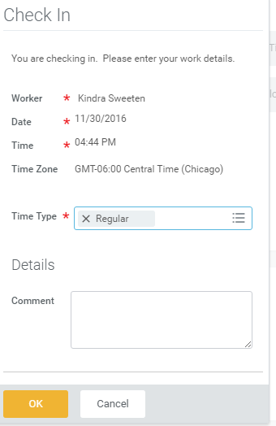

Step 4: To clock out for lunch click Check Out

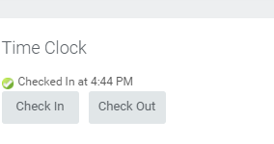

Step 5: Select Meal and click ok

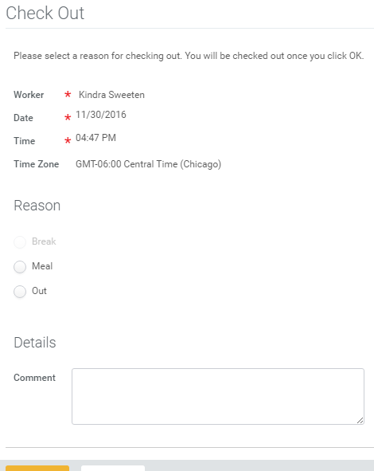

Step 6: to clock back in after lunch follow steps 2 & 3

Step 7: to clock out for the day you will click on Check Out



Step 8: Select out and click OK



# Request time off:

Step 1: from the home page click on the Time Worklet



Step 2: Click on Request Time Off

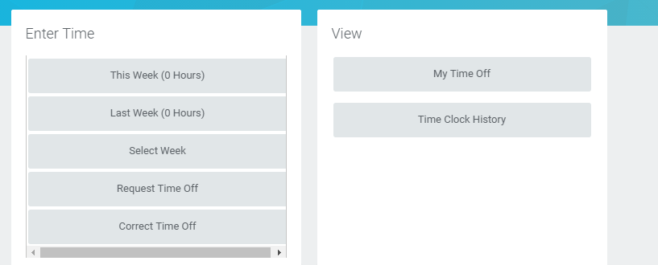

Step 3: Select the days on the calendar and click Request Time Off

Step 4: Enter the Time Off Type, daily quantity of hours requested and click submit